**Creating a Replication Instance**

* Now lets create a replication instance which will migrate the database from source to target.  
  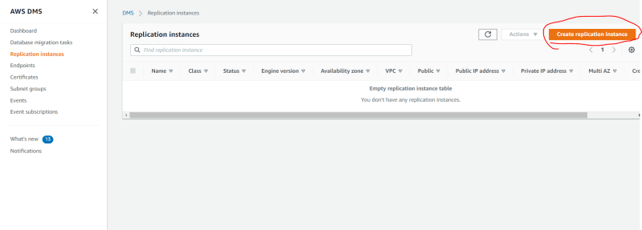  
  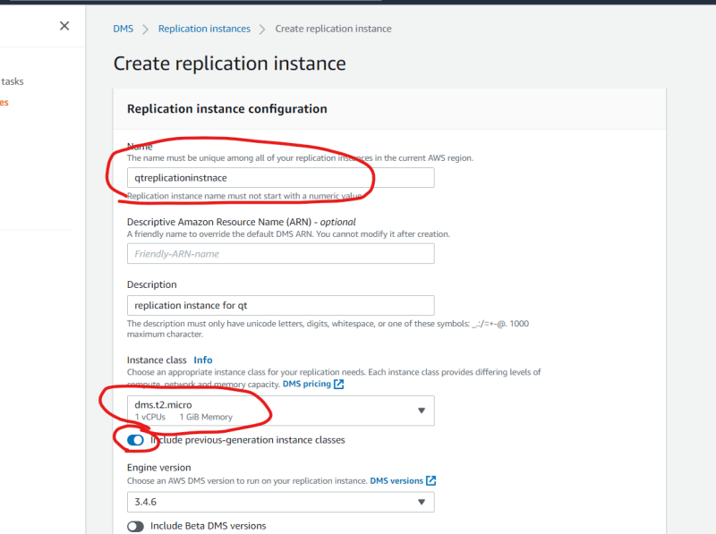  
  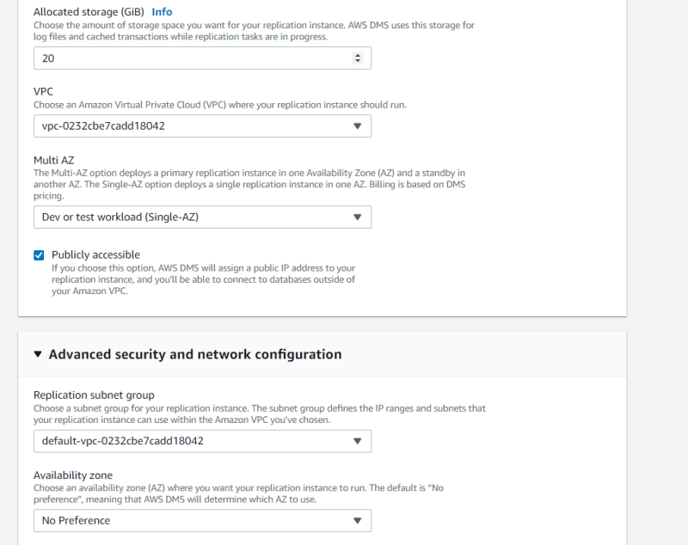  
  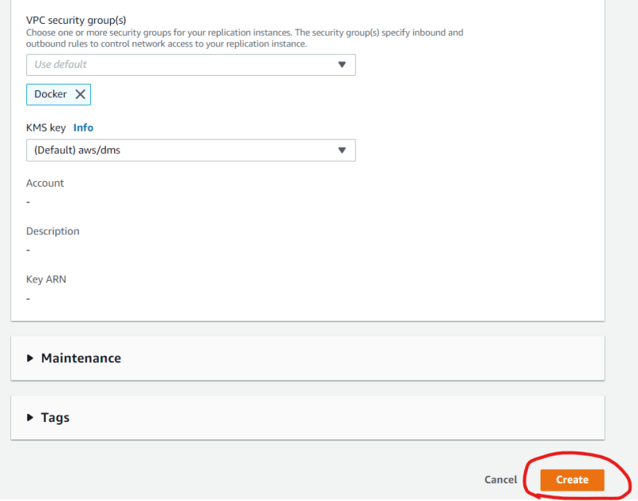
* Creation of this instance will take few minutes  
  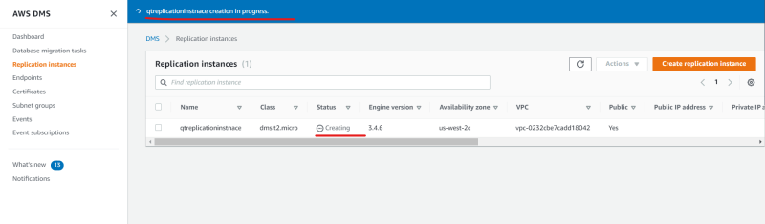  
  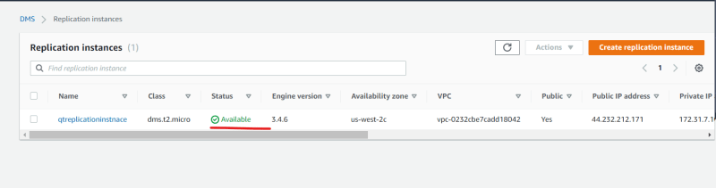
* After the Replication instance is created, we need to test the source and target endpoints  
  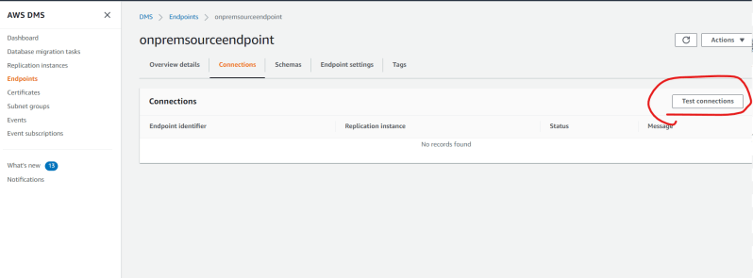  
  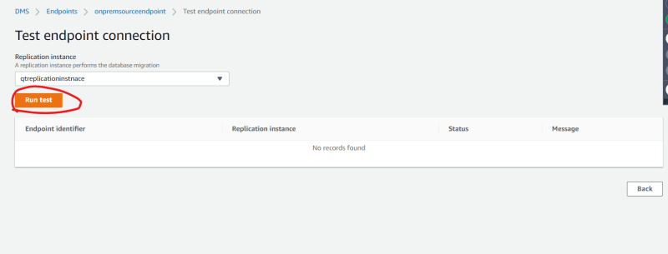  
  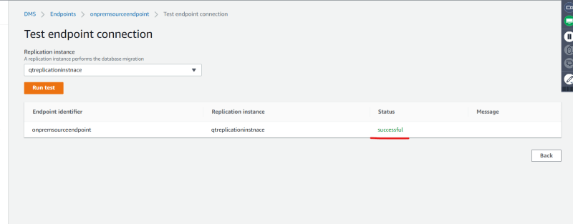  
  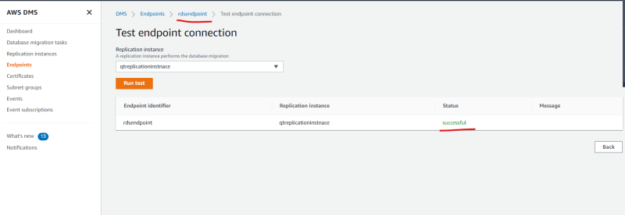
* Migration Types
* Migration existing data => one time migration
* Migration existing data & Replicate On going changes => migration & Replication Setup
* Replicate On going changes => replication  
  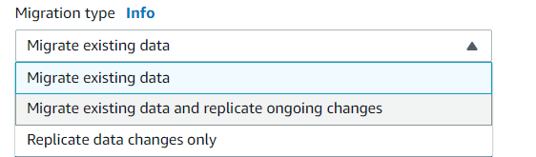
* Now lets create a replication task. For this activity we will be using one time migration  
  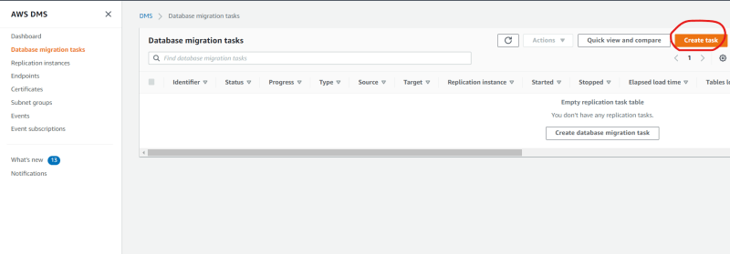  
  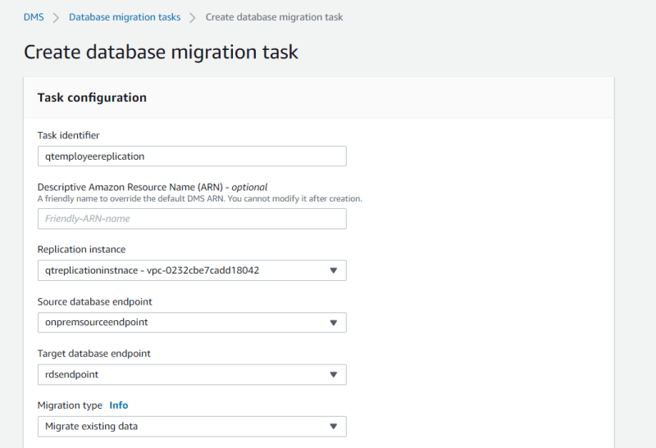  
  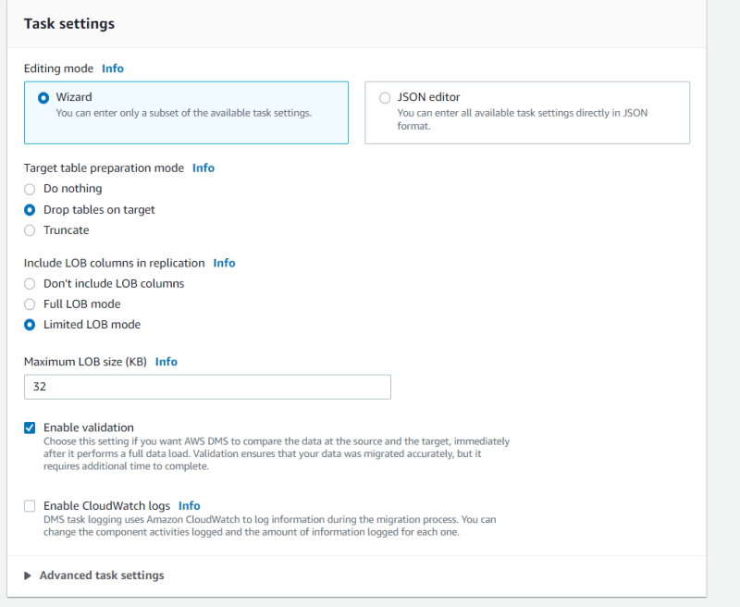  
  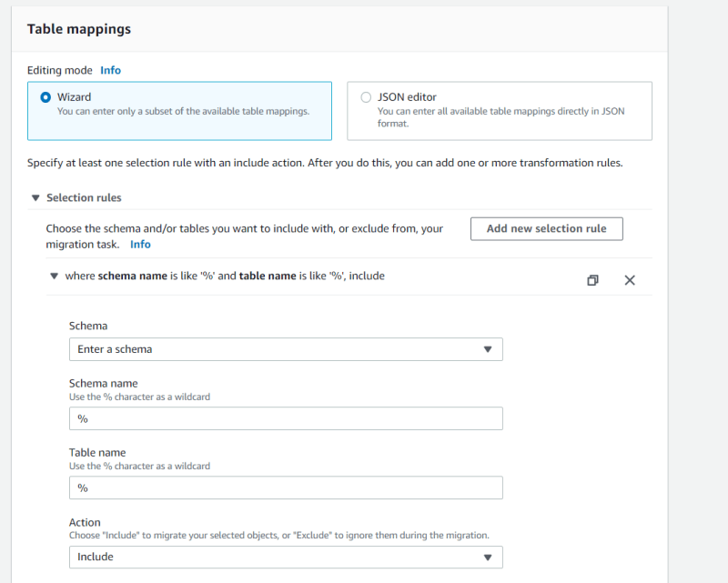  
  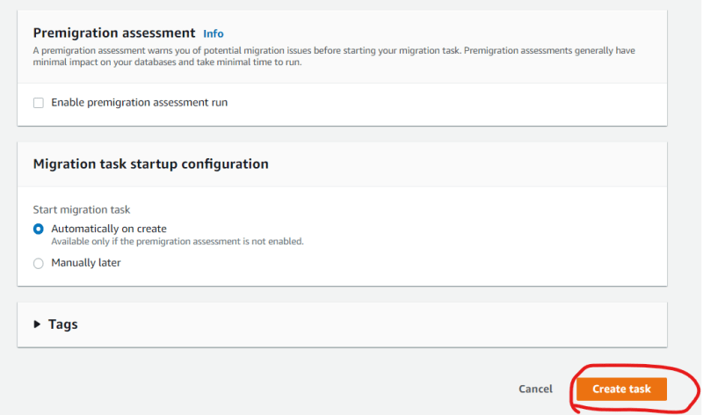  
  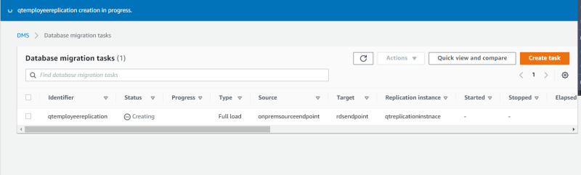  
  
* Lets change the schema to be migrated as employees and start the replication.  
  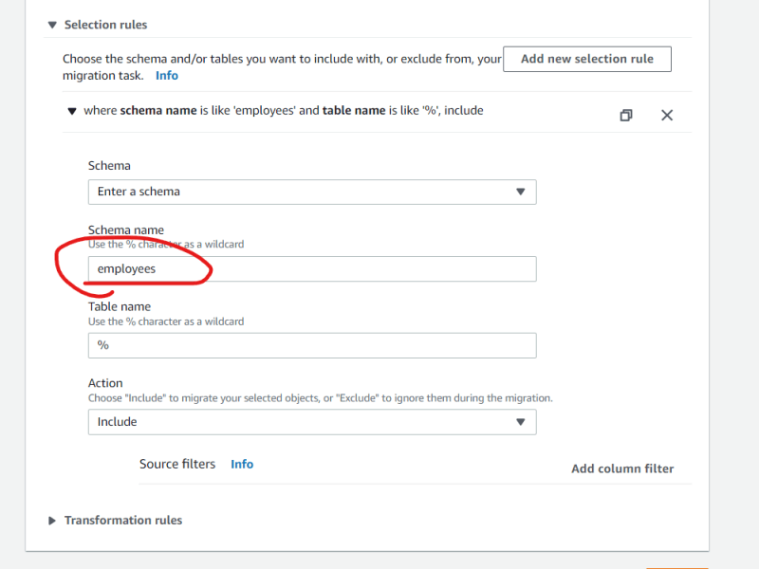
* Now Lets wait for the task to be completed  
  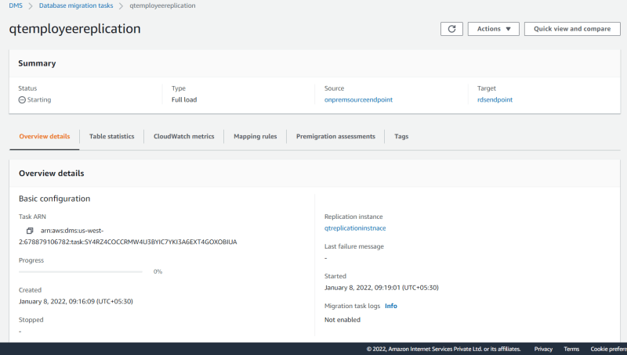  
  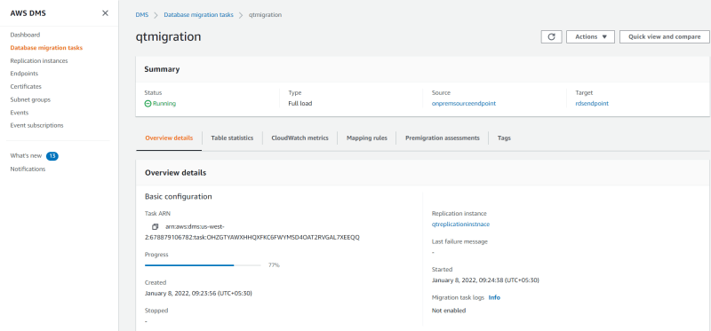
* Now to verify if the all the records have been migrated or note we can do basic checks

use employees;

select count(*) from departments;

select count(*) from dept_emp;

select count(*) from dept_manager;

select count(*) from employees;

select count(*) from salaries;

select count(*) from titles;

* If you want to replicate ongoing changes then aws displays the following message  
  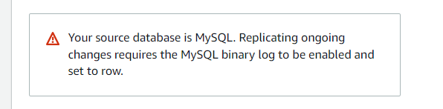
* <https://dev.mysql.com/doc/refman/8.0/en/binary-log-setting.html> for the mysql docs on how to do this activity
* Lets create a Replication task  
  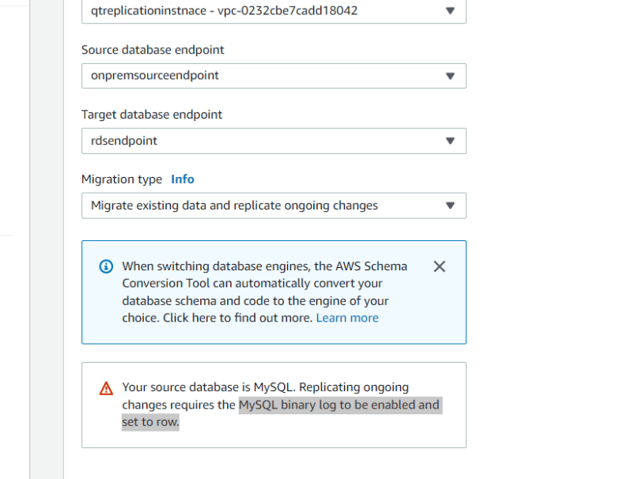
* As observed in the class if we replicate ongoing changes, the changes in the source db will automatically reach the target database
* Exercise:
* Try to setup a migration from postgreSQL running on t2.micro instance to AWS RDS with Postgresql
* [Refer Here](https://www.digitalocean.com/community/tutorials/how-to-install-and-use-postgresql-on-ubuntu-20-04) for the steps to install postgresql

**Share this:**